**TUGAS PRAKTIKUM 1 PEMOGRAMAN 1**



**NAMA : Muhamad Ary Utomo.P**

**NPM : 4513210026**

**TEKNIK INFORMATIKA  
FAKULTAS TEKNIK**

**UNIVERSITAS PANCASILA**

1. **barisbaru.java**

**Source code**

|  |
| --- |
| public class barisbaru{  public static void main (String[] ags) {    System.out.println("Nama \n Saya \n MuhamadAryUtomo.P");  }    } |

* **Print screen**

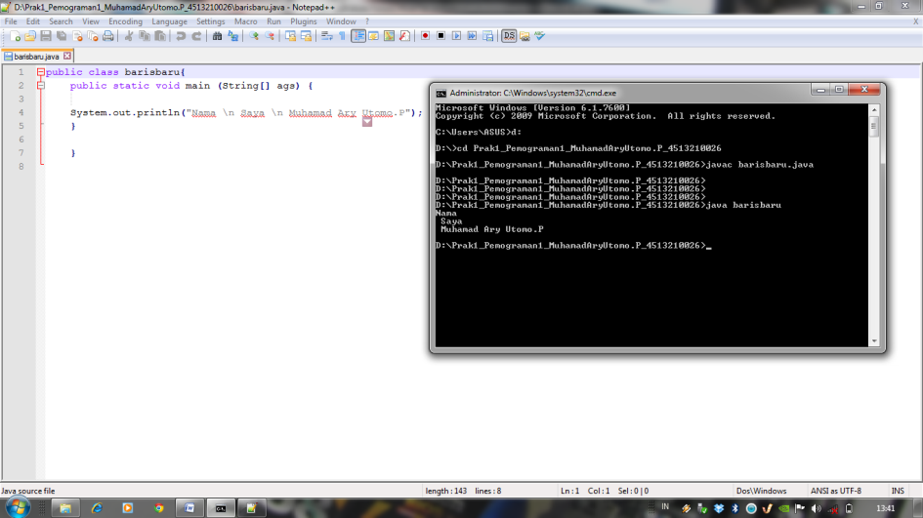

1. **welcome.java**

**Source code**

|  |
| --- |
| public class welcome4 {  public static void main (String [] args) {  System.out.printf( "%S\n%S\n%S\n" ,"Welcome","MuhamadAryUtomo.P","Java");  }  } |

**Print screen**

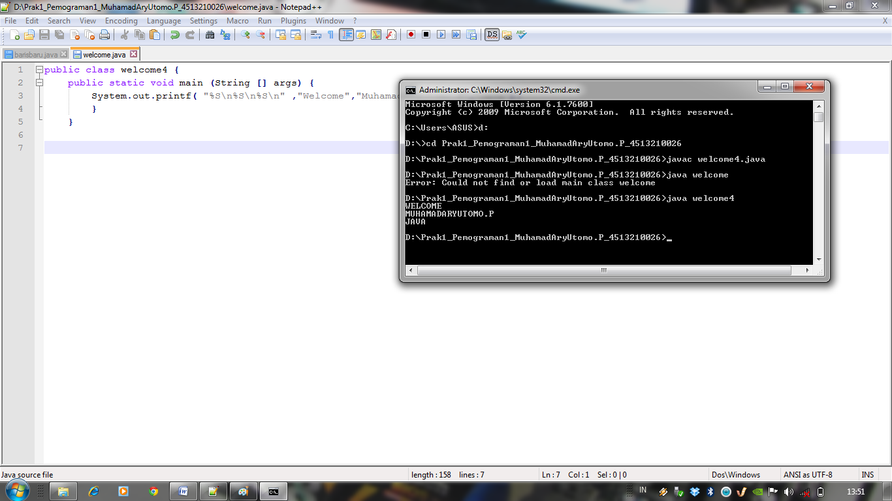

1. **masukan.java**

|  |
| --- |
| **Source code** |
| import java.util.Scanner;  public class masukan {  public static void main (String [] args){  int angkapertama;  int angkakedua;  Scanner masuk = new Scanner (System.in);  System.out.println("Masukan angka pertama = ");  angkapertama = masuk.nextInt();  System.out.println("Masukan angka kedua=");  angkakedua = masuk.nextInt();  System.out.println (angkapertama);  System.out.println (angkakedua);  }    } |

**Screen Shoot**

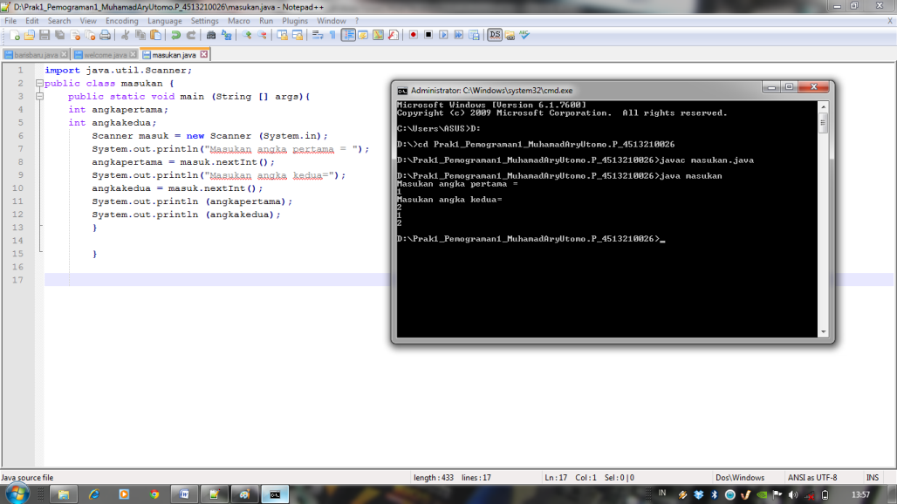

1. **masukin.java**

|  |
| --- |
| **Source code** |
| import java.util.Scanner;  public class masukin {  public static void main (String [] args){  String namapertama;  String namakedua;  Scanner masuk = new Scanner (System.in);  System.out.println("Masukan nama pertama = ");  namapertama = masuk.nextLine();  System.out.println("Masukan nama kedua=");  namakedua = masuk.nextLine();  System.out.println (namapertama);  System.out.println (namakedua);  }    } |

**Print screen**

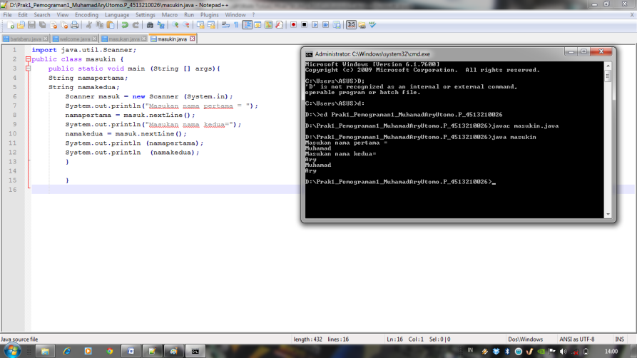

1. **data.java**

|  |
| --- |
| **Source code** |
| import java.util.Scanner;  public class data {  public static void main (String [] args){  String namapertama;  String namakedua;  String NPMpertama;  String NPMkedua;  Scanner masuk = new Scanner (System.in);  System.out.println("Masukan nama pertama = ");  namapertama = masuk.nextLine();  System.out.println("Masukan NPM pertama=");  NPMpertama = masuk.nextLine();  System.out.println("Masukan nama kedua=");  namakedua = masuk.nextLine();  System.out.println("Masukan NPMdua=");  NPMkedua = masuk.nextLine();  System.out.println (namapertama);  System.out.println (namakedua);  System.out.println (NPMpertama);  System.out.println (NPMkedua);  }  } |

**Print screen**

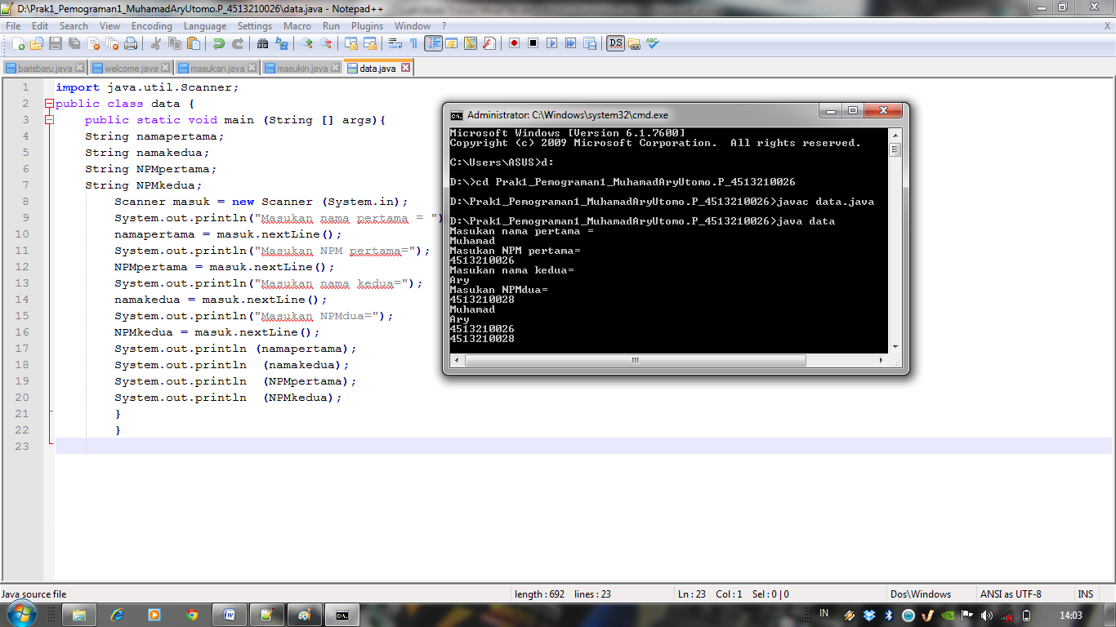

1. **hitung.java**

|  |
| --- |
| **Source code** |
| import java.util.Scanner;  public class hitung {  public static void main (String [] args){  String nama;  String NPM;  int NilaiTugas1;  int NilaiTugas2;  float NilaiRata;  float NilaiRatarata;    Scanner masuk = new Scanner (System.in);  System.out.println("Masukan nama = ");  nama= masuk.nextLine();  System.out.println("Masukan NPM =");  NPM = masuk.nextLine();  System.out.println("Masukan Nilai tugas1=");  NilaiTugas1 = masuk.nextInt();  System.out.println("Masukan Nilai tugas2=");  NilaiTugas2= masuk.nextInt();  System.out.println("rata-rata=");  NilaiRata= NilaiTugas1+NilaiTugas2;  NilaiRatarata= NilaiRata/2;  System.out.println (nama);  System.out.println (NPM);  System.out.println (NilaiRatarata);    }  } |

**Print screen**

